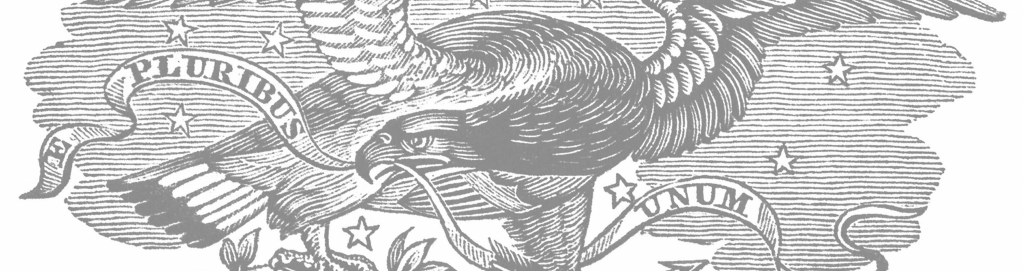
Spring 2020
THE VOLUNTEER
Sons of Union Veterans of the Civil War, New York Department

From Commander Richard Straight (From Department Communication No. 5, Series 2019-2020, January 11, 2020)
Attached is information on the 137th Department of New York Encampment. If you have any questions or concerns you can contact me at restraight1@gmail.com or cell phone (518) 344-7773
In Fraternity, Charity, & Loyalty, Richard E. Straight, Commander
JUNE 5, 2020 THRU JUNE 7, 2020 CROWNE PLAZA HOTEL, 3 EXECUTIVE BLVD SUFFERN, NY 10901 (845) 357-4800
We reserved a block of rooms for $120.00 per night. The Hotel gave us the same rate from when we had the convention a couple of years ago.
The banquet is Saturday June 6th at 7pm. The cost is $45.00 per person. The deadline is May 23, 2020.
The Plaza Dinner Buffet:
Crowne House Salad
Cucumber Tomato and Feta cheese salad, Caesar Salad

Chicken Francaise
Oven Roasted Salmon
Penne ala Vodka
Includes the Chefs Specialty Roasted Rosemary Potato or rice pilaf,
Assorted garden vegetables
Assorted Cakes

All dinners INCLUDE: Assorted soft drinks, coffee, decaf coffee and assorted teas with lemon and honey.

Make out checks to “NY DEPT DUVCW”. Mail to:
Lynne Gallaudet Dolan PDP
8917 Lyman Street
Bellerose Manor NY 11428

From Dep’t Sec’y Pugsley
Dear Brothers,
This is the time of year when things start to get busy. On June 5-7 we have our Annual Encampment in Suffern, NY. It is always a good time seeing old friends and making new ones. If you are coming please pre-register using the registration form on the website. If a delegate, bring a completed delegate card signed by your Camp Secretary. Also you need to have a current membership card.
If you are staying one or two nights, make your reservations directly with the hotel. Reservations for the Banquet can also be found on line. Also you should have received raffle tickets in the mail. Please support the Department by purchasing some. If you need more, contact Sr Vice Commander Everdyke.
At this time, every Camp should have submitted their Form 22 to me along with their current Roster. Also the Camp Annual Report (Form 27), current roster and perCapita check is due to me by April 30th.
As of this writing, we have 440 members in the Department and sixteen camps.
Lastly, 990-Ns. Please file them on time. You need to file them by the 15th of the fifth month after your fiscal year ends. May 15th if your year ends December 31 and November 15th if it ends June 30.
Feel free to contact me with any questions.
Yours in F, C, and L,
Bob Pugsley, PDC
NY Dept Secretary, SUVCW

From the Dep’t SVC, Darin Everdyke
Most of you should have found your fundraiser raffle packets in the mail by now. I’ve gotten about 60 back so far and there’s a steady trickle in the mailbox every day. Thank you to those who’ve responded.
There have been a few questions about where to send the tickets and payments. Make the checks out to The Sons of Union Veterans, Department of New York and send them to my home address at 4521 Wise Road, Groveland, NY 14462. If you would like more ticket bundles, please let me know.
To the Camp Commanders and Secretaries – PLEASE make sure your brothers’ addresses are complete and correct !!! I’ve gotten quite a few envelopes back and it’s an added expense to resend envelopes back out if/when we get a good address.
Yours, in F, C, & L,
Darin Everdyke,
NY Dep’t SVC.

From Brother Dennis Duffy

American Battlefields Preservation Act Signed by President Trump.
Hooray! And thanks to all the brothers and friends who wrote to their elected federal officials in support of this bill, now law, which provides $20,000,000 a year for the next ten years, double what was allocated over the last ten years! For the first time, part of the funds, $1,000,000 a year, will go to restoring acquired land to 1860s conditions and another $1,000,000 will go toward interpretation, leaving $18,000,000 for acquisition each year.
In fiscal 2020, $5,000,000 of the acquisition funding will be used by the National Parks Service to acquire inholding parcels for incorporation into battlefield parks- notably at Virginia's Petersburg National Battlefield and North Carolina's Guilford Courthouse National Military Park.
The American Battlefield Trust noted the leadership of the bill's sponsors, Senator Johnny Isakson (R.-Ga.) and Representative Jody Hice (R-GA.) and 17 other legislators, including New York Congresswomen Nita Lowey (D-NY) and Elise Stefanik (R-NY).

Brothers, $200,000,000 over the coming decade for battlefields preservation, which will be leveraged to produce as much in additional private donations, is a tremendous achievement, well worth your time to write to express your appreciation:

Hon. Nita Lowey, Congresswoman
Washington, D.C. Office
2365 Rayburn HOB
Washington, D.C. 20515
202-225-6506
202-225-0546 (fax)
White Plains District Office
222 Mamaroneck Ave., #312
White Plains, NY 10605
914-428-1707
914-328-1505 (fax)
New City District Office
67 North Main Street, Suite 101
New City, NY 10956
845-639-3485
845-634-4079 (fax)

Hon. Elise Stefanik, Congresswoman 318 Cannon House Office Building Washington, DC 20515 Phone: (202) 225-4611
Glens Falls office 5 Warren Street, Suite 4 Glens Falls, NY 12801 Phone: (518) 743-0964
Fax: (518) 743-1391
Plattsburg office
137 Margaret Street, Suite 100
Plattsburgh, NY 12901Phone: (518) 561-2324
Fax: (518) 561-2408

Watertown Office
88 Public Square
Suite A
Watertown, NY 13601Phone: (315) 782-3150
Fax: (315) 782-1291

We have heard that the Sons of Union Veterans of the Civil War is "a best kept secret." One way not to be a secret any longer is have your voice heard, so write, call, or e-mail and mention that you are a member of the SUVCW.

More information is on the website of the American Battlefields Trust.

Rally Round the Flags.
-The Department's Rally Round the Flags Committee is developing a matrix to identify the recruiting areas of each New York regiment so support can be elicited for conservation of each regiment's flag from the areas from which each regiment drew their recruits.
A flier which can be used to solicit donations to the special battle flags preservation account maintained by the Friends of the NYS Military Museum is on the Department website under the PROJECTS tab. Forward this to friends, or print it out and use it to send in your contribution or that of a friend. The special account at the Friends has gone from zero to $550.00 in the 90 days since the solicitation brochure was prepared and first circulated.
-Also on the website is a sample letter to the Governor and your Legislators. If you have already written and more than 90 days have elapsed, write again. If you haven't written, please do so and get your friends to write. The Governor's office and many legislators have told us that they are aware of the issue but need more letters to get it the priority it needs to be included in the budget.

Graves Registration & Head Stones Placement/Repair. Half our camps have submitted their 2019 GRO Reports, up from only one last year! That's a huge improvement. If your camp hasn't yet sent its report in, e-mail Department GRO Dennis Duffy at duffy99999@aol.com or 516-593-4014 and he will send you a blank form to complete and return. Find out who your Camp's GRO is and volunteer to help him in this important work.

New York Civil War Sites. The following 501(c) 3 organizations in New York share our mission of Remembering the Boys in Blue.
They can use and will appreciate any donation you can afford. Check out their websites to see what great work they are doing and, when you're in their areas, pay a visit!

-The National Memorial Day Museum (wlhs-ny.com/national-memorial-day-museum) is planning to relocate next to its parent, the Waterloo
Library & Historical Society, so it can be heated and staffed for year 'round operation. Donations can be sent to: Waterloo Library & Historical
Society 31 E. Williams St., Waterloo, NY 13165

-Elmira Civil War Prison Camp (elmiraprisoncamp.com). Donations to: Friends of Elmira Prison Camp, PO Box 681, Elmira, NY 14902
-Echoes Through Time Learning Center and Civil War Museum (echoesthroughtime.org). Executive Director is Bro. Steven Teeft of Chaplain P. G. Cook Camp #223. Donations to: Echoes Through Time, 39 Main Street, Springville, NY 14141

-Citizens Advocating for Memorial Preservation (CAMP) (www.cattcomemorial.com). In 1914 Cattaraugus County erected the Civil War Soldiers and Sailors Building in Little Valley, NY in honor of those who served. The County's recent decision to demolish this historic structure sparked a grass roots effort resulting in the formation of CAMP which has saved and is renovating the building. Once the building is ready, it
is planned that Echoes Through Time will relocate there. Donations: CAMP has partnered with Cattaraugus Region Community Foundation (CRCF) to allow donations made to CAMP to be tax deductible to the donor. When making a contribution by check, please make it payable to CRCF with
“RESTRICTED TO CAMP” on the memo line and mail to: CRCF,
301 N. Union St., Olean, NY 14760

In Fraternity, Charity, and Loyalty,
Bro. Dennis
Dennis J. Duffy, Secretary-Treasurer, Moses A. Baldwin Camp #544,
Chair, Legislation Committee & Graves Registration Officer, Dept. of NY, SUVCW
One Garden Drive
Lynbrook, New York 11563
516-593-4014 duffy99999@aol.com

From George J. Weinmann, PDC
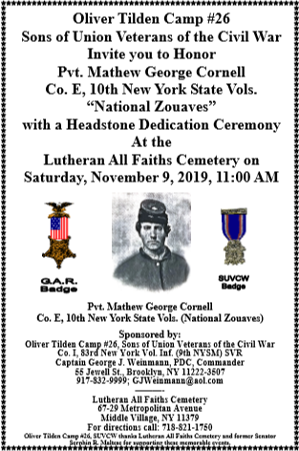
On Saturday, November 9, 2019, Oliver Tilden Camp #26, Sons of Union Veterans of the Civil War and Co. I, 83rd NYVI Sons of Veterans Reserve
honored Pvt. Mathew George Cornell, Co. E, 10th New York State Vol. (National Zouaves) with a Civil War headstone dedication for his military service. The ceremony took place at 11:00 am in Lutheran All Faiths Cemetery in Middle Village, Queens, NY.
Commander George J. Weinmann, PDC lead the Color Guard and conducted the grave site ceremony. Pvt. Mathew George Cornell is Tilden Camp member Alex Pappas' ancestor. His family was invited to the ceremony. Bro. Alex spoke about Pvt. Cornell's life before, during and after the war. Special guests were in attendance. Actor Patrick Falci who portrayed A.P. Hill in the movie Gettysburg and John Shaud, PCC of Moses A. Baldwin gave remarks. About 30 family, friends and members were in attendance to honor Pvt. Mathew George Cornell, Co. E, 10th New York State Vol. (National Zouaves).
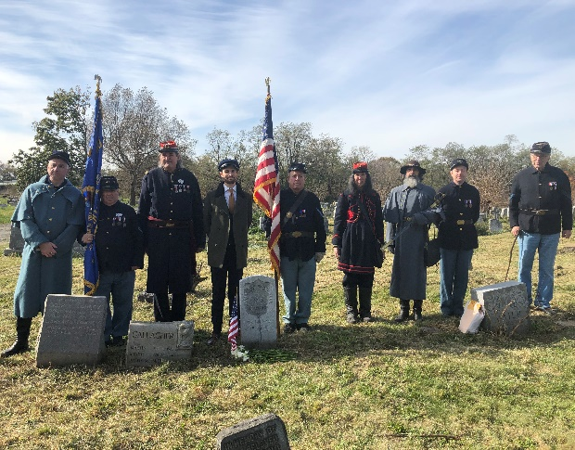
FroFrom Roland Neiss, D.G. Caywood Camp #146
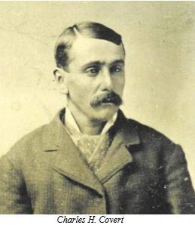 PRIVATE CHARLES H. COVERT 137TH NEW YORK VOL. INFANTRY by George Shadman, PDC
Charles H. Covert was born in the town of Windsor, Broome County, New York in 1834 to James and Mary Delamater Covert. His life was spent in Windsor. He married Phoebe Marble on October 6, 1853 and over the next ten years they had six children, one being Sarah Elizabeth, my great-grandmother.
Charles worked as a farmer in Windsor up to his enlistment into Company B, 137th New York Volunteers on August 12, 1862. The regiment was organized at Binghamton, NY and was mustered into service for three years on September 26, leaving the State the next day.
They served in the Third Brigade, Second Division, Twelfth Army Corps, in which they participated in the Battle of Chancellorsville, Virginia, and in July 1863 they found themselves at Gettysburg where they went into battle with only 525 men in the ranks; when they left New York they were 1,000 strong.
On July 1st, they found themselves on the right flank on Culp’s Hill. The men immediately began to throw up breast works. It was on this part of the battlefield they would remain until the end of the fight. The night of July 2nd and into the morning of the 3rd, the rebels made four distinct charges. It was here that Private Charles H. Covert was wounded. The fighting was fierce. “The officers and men behaved admirably during the whole of the contest. Colonel [David] Ireland was attacked on his flank and rear, he changed his position and maintained his ground with skill and gallantry, his regiment suffered very severely.” [New York at Gettysburg, page 942]
After Gettysburg, the 137th joined General William T. Sherman’s Western Army and was now with the Twentieth Army Corps. They participated in the Atlanta Campaign. It was during this expedition that Private Charles H. Covert came down with fever and was transferred to the Corps’ hospital which was located in Stevenson, Alabama. He died on March 9, 1864 and was buried in a cemetery near the hospital. Later his body was moved to the Chattanooga National Cemetery in Tennessee.
Private Charles H. Covert is the great-great grandfather of Bro. George Shadman, PDC, a lineage on his mother’s side of the family tree.

(Editor’s note – spelling and grammar have been intentionally left in their original form)

GRAND pa and Me

Adolph's mother, Bertha Schumann brought her son, my grandfather here from Berlin, German to America for one reason, at age 11 to be sure he was not inducted into the Germany army.
So what did this typical boy do, he volunteered into the Union army of the Civil War when he was 15 in New Jersey. He joined the light artillery, Battery C, First Reg. N. J. Vol. In 1864 he was promoted to Corporal and stayed until the end of the war in 1865. He had joined in 1863 and was sent directly to Gettysburg where he heard Abraham Lincoln give his famous speech.
When I was small my Grandma had passed away and he came to Brooklyn to live with us. My brother and I were particularly interested in a Sunday cartoon called the Katzenjamer Kids who played tricks on grown ups. We imitated the cartoon, with our own brand of tricks. My brother would tie a string to grandpa's pipe and place it on the floor. As an innocent little girl aged 3 years I would say, "Is that you pipe Grandpa?" When he tried to pick it up, my brother would pull the string. We would climb up and look through the transit at night when he was taking a bath. And he is chamber pot to the bed, making it difficult for him to get.
We finally moved to an apartment on Bushwick Ave. Grandpa married again and moved to the house next to us. Grandpa was my father's father and he married my mother's mother. Every day he sat in the bay window waiting for me to come home from school. I thought he had gotten enough of our tricks but evidently not. He was so happy to play pinochle with me and tell me stories of the Civil War days. He had a large rocker in the kitchen with a picture of Abraham Lincoln over it. There he explained how tired he was on guard duty and as he walked he fell asleep but kept walking. And the hard tack he ate but was glad to get it even though the maggots were crawling out of it. He finally asked how I could win so many pinochle games when he was a good player. I finally explained I would see his hand in each glass of his glasses. Unfortunately he was unable to play without glasses. So I able to win many games.
Not many grandparents would stand for the antics of such grandchildren. But alI can say I had a grandfather with oceans of patience and I enjoyed every minute I spent with him. I marched in many parades on Memorial Days with a red, white and blue dress and he carried his huge sword which now hangs over my open fire place. I am so glad to have lived in a era of family orientation. We had plenty of patience and security. Since my mother thought her son a wonderful person I must really be wonderful and felt completely secure when near him. My brother was four years old than I. Since we lived in a cold water flat, it was his responsibility to carry up the coal and wood three floors and help start the coal stove in the kitchen every day. He would wire around an oatmeal box and placed the crystal in a cut glass bowl so the whole family could hear the first radio programs from a round table in the kitchen. I do not have a great deal of sorrow for poor people for we had little money but so much love for family and interest in making our own entertainment. Today families live so far away and have everything at their fingertips. They do not have reasons to work together and know one another. Tomorrow will be Jan. 01, 2003. For the New Year I wish you all learn just how wonderful your family is and know just what is real Happiness.

Emeline S. Eberlin Past President DUV, Kady Brownell Tent #36
Rufus King Ch. Past President DAR
Founders Chapter Past President, Colonial Dau. of the 17th Century
Age 97.

Adolph Schumann belonged to Brooklyn City Post #233, Grand Army of the Republic.

In September of 1979 I met Emeline Eberlin outside the former Carnegie Library in downtown Syracuse, N.Y. She was wearing her DAR ribbon as she attending the annual meeting of the DAR.
She said she would considering joining the DUVCW if I would join the SAR. We both kept our promise to each other. She even joined the Ladies of the Grand Army of the Republic.

Emeline was a dignified lady if there was ever one. She and a friend traveled with steamer trunks through the Panama Canal in the 1930's up the west coast and back home to NY.

I asked her to write a few memories of Civil War grandfather and after several requests this what I received, via email!

She died on November 2, 2007 at age 101. This is a small memorial to her and her most productive and useful life.

Typed by her friends,

Jerome Orton, PDC, Dept. Historian, Sons of Union Veterans
Lorraine Orton, PDP, National Historian, Woman's Relief Corps

John Goodnough, Secretary, Col. David Ireland Camp #137

TAKE THIS RARE OPPORTUNITY FOR RESEARCH, by Brother John Goodnough, Col. David Ireland Camp 137 (Binghamton, NY and vicinity). Now that we seem to be under virtual "siege" by the threat of the expanding Corona-19 virus, many of us members, including those over age 65, are lately virtual "housebound prisoners" with much time on our hands. What better opportunity than to try working toward filling in data on thousands of former New York Civil War veterans? With few exceptions, when each of us made applications to become members, we drew on what we knew about ancestors in our family lines who had served in the Civil War to support our petitions for membership. In 2003, I became a member of the local Round Table, and soon found myself volunteering to serve on committees. One of them was dedicated to research on local soldiers. After spending much time going through public access records in local repositories, I soon became acquainted with the growing number of sources available on the Internet that aided me in my endeavors. Things learned were of benefit when in 2016 I also became an active member of SUVCW Col. David Ireland Camp 137 in Binghamton. Along with Brother Willis Platt, I got immersed in several aspects of the research process, and learned what resources gave the best results, along with some to stay away from.

Today the New York Department contains around 450 members of record. Extant sources indicate that at least 450,000 men were sent to serve in the Civil War from New York, the single largest contributor of manpower to the Union Armies and Navy. Although numerous rosters and sketchy service records are easily available, it takes some heavy digging to uncover most of the underlying "nuts and bolts" about a civil war soldier or navy man's service.

If every member of the New York Department would take up researching several soldiers (not necessarily from their family lines), a big dent could be made in the massive project to uncover substantial reference material about large representative groups of the men from 1861-1865. It would be near impossible to complete even in our lifetimes, but an excellent foundation for those who would be future beneficiaries of the data. In my own experience from going through hard and electronic files, I've become so familiar with some of the old veterans that I feel like I know them personally. In cases of many others, though, data is elusive. For those who haven't explored this avenue seriously so far, one of the best places to begin would be to access U.S. Civil War military files available via links from Ancestry.com. This will provide most of the basic information on the common soldiers and also can produce a plethora of material on field and staff officers. Data on the latter can be found in generous quantities if one has access to NEW YORK IN THE WAR OF THE REBELLION (Phisterer) reference books. After a few years of research, I found data on nearly 70 men from my own family lines who served in the Civil War here in New York State. They were descended from three brothers and one sister who came over as emigrants from England in 1638. Some learned members of my family genealogy association put me on the track of many of the New York soldiers bearing the family name, and with the help of the continually available programs tied to Ancestry.com, many doors were opened. Believe it or not, one can also find some valuable information from a site such as the oft-referenced Fulton Post Cards (often carries Civil War veteran obituaries from archived old newspapers around New York State). If one wants to locate bits of data on their Civil War ancestors from the service aspect, take a look at such sites as the New York Civil War Muster Roll Abstracts, the New York Adjutant General's Reports, the New York Town Clerks' Registers of Men Who Served in the Civil War, the U.S. Civil War Pension Index, and the 1890 Special Veterans' Census, also found "on line." In some instances, the FOLD-3 site may be of help. If attacking the project via seeking records from the U.S. NARA, that path can prove to be costly, especially if one wants to obtain service, pension and medical records. Everyone approaches things differently, but once you find a system that works, and you're comfortable with the outcome, make the best use of it!

A typical end-product biographical sketch should include addressing the following: Veteran's Name and its known spellings; Date and Place of Birth; Names of Parents (if known); Known Occupation(s); Residence in the 1860 U.S. Census (the last one prior to the outbreak of the war); Marital Status. Was the soldier drafted?; Civil War Service (dates of enlistment &, muster, beginning rank, name and number of unit, State served). Were they wounded, captured, discharged for disability, or killed/mortally wounded?, Were they promoted or demoted? Physical description. Discharge date and place. Anything significant about their post-war life, if they survived the war. Pension applications; were they canvassed during the June, 1890 Special Veterans' Census? Date and place of death, and location of interment (See FindAGrave). Were some of them interred in national cemeteries? How about their membership in the G.A.R.? All of the above can also later be transferred to respective columns or blocks on SUVCW Form GR. NY Department Graves Registrations Officer Dennis Duffy would be pleased to ultimately receive it!

So don't plan on being idle while any "down" time seems to hover during this possibly lengthy period under "quarantine," self-imposed or otherwise.

Respectfully submitted,
John Goodnough, Secretary,
Col. David Ireland Camp #137

• • •

From Bro. Steve Reilly

When Brother Rich Reilly of Tilden Camp, was attending High School on Long Island. He said to his dad, “I want to follow you onto the Cops, but I want to do the Army also”. He had heard about Norwich Military University in upstate Vermont from a friend, who was current cadet. The University asked Rich to come up, and stay overnight with his friend. The next day, as he was checking out to return home, a member of the admission department advised him, that he has been accepted to the Corps of Cadets.

As he was nearing the end of his four years, he had pick which road to follow. Go with many of his fellow Cadets into the active Army, or go reserve and onto the New York City Police Department. His father, wanted him to follow in his footsteps and join the State Police, but Brother Rich joined NYPD and is now a Detective in Brooklyn South.

At the same time, he joined the 69th New York National Guard (Fighting69th) where his Great Grandfather had joined in April of 1861 along with his big brother Bernard. Bernard was later killed in action at the North Anna River and is in Arlington Section 27, grave 411. Bro. Reilly's Great-Great grandfather Philip Reilly, fought at the first Bull Run and lived to see General Lee, hang out the White Flag. Bro. Reilly's granduncle Jimmy, joined the 69th in 1939 as a Pvt. and ended WW II as a Captain.

Brother Reilly, went up the ranks in the 69th, until he was the Commanding Officer of Delta Company, Heavy Weapons. As his time of command was coming to an end, he was told that he was being transferred to the 42nd Division, a Division that his Grandfather served in, during WW II.

When he arrived at Division Headquarters, he was told that he is the incoming Aide de Camp to the Commanding General, and that they are being activated and sent to the Middle East. Where the General will be the Commanding General of Task Force Spartan Shield. Captain Reilly, his General along with 600 soldiers of the 42nd Division left Texas, on March 6, 2020 at 2036 and headed east.

Brother Steve Reilly,
Oliver Tilden Camp 26

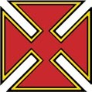
Department of New York
THE VOLUNTEER
Spring 2020
Department of New York, Sons of Union Veterans of the Civil War

SONS OF UNION VETERANS OF THE CIVIL WAR

Dep’t COMMANDER- Richard Straight PCC
SR. VICE COMMANDER- Darin Everdyke PCC
JR. VICE COMMANDER- Perry Cleaveland PCC
SECRETARY- Robert L. Pugsley PDC TREASURER- Jeffrey Albanese PDC COUNSELOR- Danny Wheeler, PC-in-C COUNCIL-Paul Ellis-Graham, Daryl Verstreate PDC, Ray Wheaton PDC
137th Encampment - Department of New York-
Sons of Union Veterans of the Civil War will be the Crowne Plaza Hotel, 3 Executive Blvd, Suffern, N.Y. 10901… June 5-7, 2020.
ARCHIVIST- Lance Ingmire
PATRIOTIC INSTRUCTOR- Richard E. Straight
HISTORIAN- Jerome L. Orton PDC

CHAPLAIN- Rev. Dr. Mark D. Isaacs
GAR HIGHWAY OFFICER- Matthew J. Hereford PCC
EAGLE SCOUT COORDINATOR- Brian Castler
GRAVES REGISTRATION- Dennis Duffy
WEBMASTER- Ray W. LeMay PDC
Newsletter Editor – Darin Everdyke
wiseacres1@frontiernet.net

